Baruch College, 8-2-20 Prof. Tatum
CIS-STA 3920 Final Project Assignment
DUE: 9:00 PM, Saturday, Aug. 15th , 2002

Submit project on the designated Portal. I urge you to not wait until the last minute to submit the project as it could happen that the Baruch server will freeze up and your work will then be late.

Overview
- Select either SVM (“support vector machines”) or CART (“classification and regression trees”). Walk through the ISL example, show your work, and discuss what you problems you encountered and what you learned.

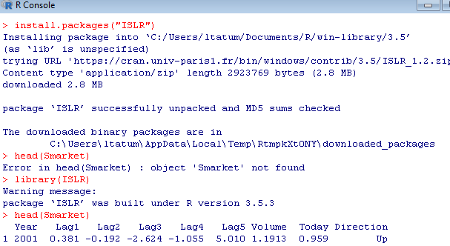
You will probably need to download an R package called “ISLR” that contains the data sets used in the ISL text. Here is a screenshot of that download, showing that we can in fact access the Smarket data set for the ISL text in this way. You will need access to the ISL data to work through the ISL text material.

Do not plagiarize the ISL graphs: make sure all the graphs shown in your project are identifiably generated by you by putting your name in the title of any plot!

- Apply your chosen methodology to both:
(A) your stock range data;
(B) the Cardiac data set (from NIH).
Include the same level of graphics used during the semester, including use of “classification space” graphs.

- Compare the performance of your new classification method against those we have used, including knn, naive Bayes, and logistic regression.

- Along with your write-up in Word, submit the R file in which you did your work, with your data included in the R-file.

Showcase your ability to produce a well-crafted document, your capacity to learn how to do something challenging on your own, and your ability to engage with the reader and to explain what is happening. If asked for a letter of recommendation, I would hope I could without hesitation include excerpts from your project as concrete evidence of your abilities.
In terms of formal structure, show the following:
1. A cover page with an interesting title and picture – the goal is to encourage the reader to continue! Do not plagiarize the picture – either make your own image or cite the source.
2. A well-formatted Table of Contents;
3. Numbered pages;
(cont.)
4. Clearly cite the page numbers for any code taken from ISL. Any text taken from ISL must be placed in quotation marks and the source cited formally and in footnotes. Use footnotes: it is NOT enough to list a source as the end of your project and then claim you did not plagiarize! The same is true for any text or images taken from the Web or books or articles. I want to see zero plagiarism.

INSTRUCTIONS FOR SUBMITTING FINAL PROJECT

Use Project Portal on Blackboard. Try zipping your project if it is too large to be accepted by BB.

